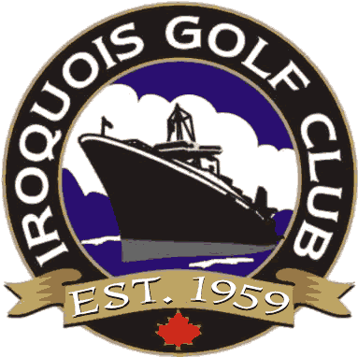
10912 Golf Club Road
Iroquois, ON K0E 1K0
(613) 652 - 4367

2026 Private Cart Use Agreement

Private Cart Users (who have paid in full a Trail Fee) may use said cart during the 2026 golf season subject to the following Conditions:
- Only individuals 16 years of age and older may operate a golf cart.
- No more than two riders and two golf bags are permitted on a cart.
- Only those individuals registered (maximum 2, at least one of which must be an Iroquois Golf Club Member) are permitted to operate or ride in cart. Private Carts may not be loaned to other golfers. Users may, on occasion, allow a non-registered rider to ride with a registered user ONLY AFTER a $20.00 fee for 18 holes / $14.00 fee for 9 holes is paid at the Pro Shop.
- Periodically and under special circumstances (i.e. when the Pro Shop makes up the team for a Club Event, Private Cart Users will not be charged a fee to ride on a club owned cart. However, when members make up their own teams for a club event (i.e. ladies twilight, men’s night, twilight closing etc.) private cart users will be charged a $20.00 fee for 18 holes / $14.00 fee for 9 holes per person to ride on a club owned cart. Cart fee to be paid at Pro Shop.
- Use of a Private Cart is subject to course conditions and may not be allowed at certain times during the season at the sole discretion of the Grounds Superintendent and/or Pro Shop Staff. Seasonal Carts are subject to availability.
- Private Cart Users must maintain their cart in good mechanical and aesthetic condition. Failing to do so, the Golf Club reserves the right to suspend privileges at their discretion until such time as repairs are made to the satisfaction of the Club.
- Private Cart Users shall indemnify and save harmless the Iroquois Golf Course, their officers, employees, contract workers and volunteers from and against any liability, loss, claims, demands, costs, and expenses, including legal fees, occasioned wholly or in part by any negligence or acts or omissions whether willful or otherwise by the user or any persons the user is responsible for.
- Private Cart Users agrees to pay or reimburse the Iroquois Golf Club for any damages to property or equipment caused by the “USER” during the use of the cart whether willful or otherwise.

Names of Authorized Users _____________________________________________________

_____________________________________________________

Signed this ___________ day of _________________ 2026, at Iroquois, Ontario

_________________________________________ ________________________________________
User Iroquois Golf Club Staff

